Carbon Capture and Storage Technologies

Student’s Name
Department, University
Course Number and Name
Instructor’s Name
Date

Abstract
The huge demand for energy in the past century has seen the emission of CO₂ to the atmosphere increase due to the use of fossil fuels in power plants. This has resulted in climatic changes that today threaten our survival. Effective strategies are thus required to decrease these emissions there countering climate change. Carbon capture and storage CCS have been touted as the best method to reduce CO₂ emissions while using fossil fuels in the generation of power. This paper has reviewed four critical methods of CCS technologies that might be used in the large-scale capture of CO₂ generated in the power industries. The methods of chemical loop combustion, pre-combustion, post-combustion, and oxyfuel combustion have been discussed in length with regard to their design, cost and reliability, and barriers to their large-scale deployment. Among the four CCS technologies, the paper suggests that chemical loop combustion (CLC) is best fitted to reduce CO₂ emission.

Introduction
The increased release of carbon dioxide (CO₂) is causing many problems to the atmosphere, thus leading to global warming due to climate changes. Over the world, concern over climate change’s detrimental effects has continued to mount (Sifat and Haseli, 2019). Several international and national environmental bodies have taken the opportunity of creating awareness of the dangers of increased amount CO₂ in the atmosphere. Their primary focus of them creating awareness has been anchored on reducing CO₂ emitted to the atmosphere through the different energy sectors. It has come to be widely accepted, though some skepticism also exists, that these changes are to a great extent anthropocentric due to our ever-increasing consumption and reliance on fossil energy resources which is not about to go down any soon. One of the major goals of fighting the climate change effects has been stabilizing atmospheric CO₂ levels at 550ppm, which is key to limiting the long-term warming to 2-3ºF and avoiding harsh environmental consequences (Matsuno et al., 2012).
The ever-increasing population and the need to grow economies make it unlikely that the world would readily give up fossil fuel use even though there exist alternative energy sources. Currently, 80.6% of the world’s energy is harvested from fossil fuels, and this will continue to be so, probably even in the next century, as indicated in figure 1. Thus, since peoples’ affinity to using fossil fuels cannot be changed anytime soon to save the world from global warming, technology has always been touted as the best available option to help reduce carbon emission into the atmosphere. 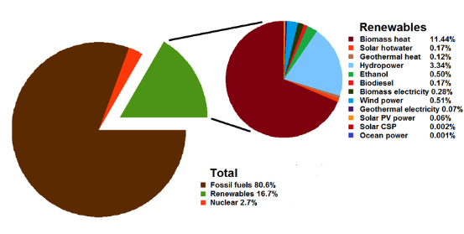
Figure 1: Total world energy consumption by source
Inasmuch as the technology can help reduce emissions, one needs to note that no single technology option can help achieve the stabilization goals. The achievement of this goal requires a portfolio of mitigation strategies and measures that include renewable sources such as geothermal, wind, solar, and nuclear energy. In recent decades, one of the most industrious and brilliant solutions that have emerged has been the idea of capturing CO₂ from significant industrial and energy-related point sources. This technology plays an important role in the portfolio of measures whereby the CO₂ is captured, transported to a predetermined site, and stored underground for a considerable time, such as hundreds and thousands of years (Bui, et al., 2018). This technology process is referred to as carbon capture and storage (CSS). Figure 2 shows how the CSS process.
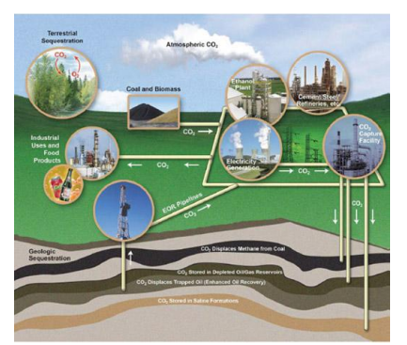
Figure 2: CCS process and potential CO₂ utilization or storage options
Literature Review
The CSS is a process where carbon separation technologies are deployed in industries or on fossil-fueled power systems to harvest the CO₂ and mitigate its release. CCS’s technological process is not entirely a new idea; this process has been used in commercial operations over the past decades, especially in the oil and gas industry, whereby CO₂ has continuously been injected into oil formations to harvest additional oil. CSS technology plays a critical role in today’s century as far as climate change is concerned (Zainab and Oboirien, 2020). Studies have indicated that the inclusion of CCS in the mitigation portfolio has helped reduce the cost of stabilizing CO₂ concentrations by 30% or more (Matsuno et al. 2012). CCS usually allows for a smooth transition away from fossil fuel economy since most of the technology for storage is already established. Through enhanced oil recovery (EOR), the technology allows for economic benefits, thus becoming low emission opinion and becoming low emission for industrialized countries such as China and India, whose use of fossil fuels has continued to increase exponentially (Zainab and Oboirien, 2020). The CSS process has three essential steps; capture, transportation, and storage.
The CCS process of capturing is achieved in different ways, but the main ways include pre-combustion, post-combustion, oxy-fuel, and chemical looping combustion (CLC). The post-combustion process involves the separation of CO₂ from piped gas by a chemical solution after the primary fuel combustion. The pre-combustion process involves transforming primary fuel to produce hydrogen; before the combustion process, the CO₂ is removed (Bui, et al., 2018). The oxy-fuel combustion, which is the third process, involves burning fuel in an aerobic environment, resulting in the CO₂-rich waste gas stream. The CO₂ released is captured, compressed, and made ready for transportation to the designated site (Bui et al., 2018). The CLC, on the other hand, is a fuel oxidation process with inherent CO₂ separation whereby the oxygen is provided to fuel through a solid metal carrier which is usually a metal oxide. Figure 3 provides an illustration of potential CO₂ sources which may deploy CCS and utilization or storage options for CO₂ captured, and how some of these technologies operate.
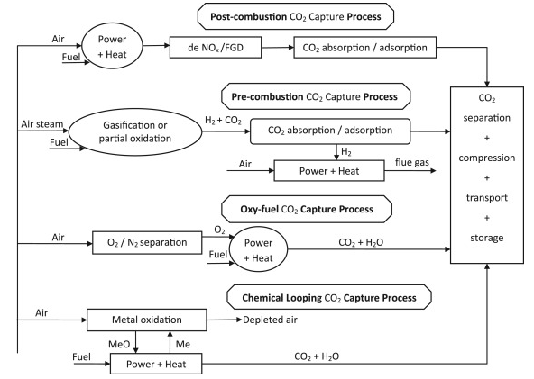
Figure 3: CO2 Capture technologies
CCS technologies have been touted by various organizations as being key to the realization of a comprehensive reduction in CO₂ emissions. Many of these organizations believe that by 2050, energy-related CO₂ emissions will have been halved globally (Thompson, 2014). The figure 4 shows an illustration of the International Energy Agency’s Blue Map Scenario of how the halving goal will be achieved by 2050 through a least-cost means.
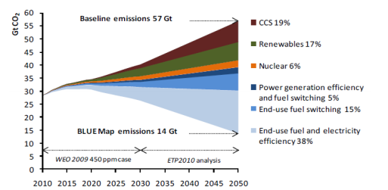
Figure 4: IEA BLUE map scenario
Besides the capturing process, there is the transportation aspect of the CCS. To a great extent, the technological infrastructure for transporting CO₂ is already in existence. Historically, oil companies have been transporting CO₂ to enhance oil recovery and transportation of natural gas (Abdelaal et al., 2020). Thus, with the already existing extensive transportation network of pipelines, the transportation of CO₂ is always not an uphill task. Inasmuch as that is the case, the existing extensive transportation network can only support a considerable number of companies or organizations. CSS's large-scale deployment requires more pipeline infrastructure, even though it may also be conducted in tank wagons and ships (Kelsall, 2020). The cost of transportation is usually dictated by quantity, distances, and geographical conditions. Compared to the capture cost, transportation costs are less though it might be expensive for companies that do not possess the CSS transportation infrastructure.
CSS's third technology process involves safely storing CO₂ in deep geological formations for many years, even a century (Kelsall, 2020). The appropriate land for storing the CO₂ may include:
- Depleted oil and gas reservoirs.
- Deep saline aquifers.
- Seabed.
- Un-minable coal seams.
Studies have suggested that the saline aquifers hold the largest potential capacity for storage. For the saline aquifers, the storing process includes injecting CO₂ deep underground into the sandstone layers where the gas is contained by the natural pressure of the impermeable non-porous cap rock layers above (Bachu, 2015). In recent years, the reliability and safety of the storing process led to the emergence of key issues. Another issue that has emerged is the uneven distribution of these storage sites. Inasmuch as these issues are yet to be followed up, there is a great deal of uncertainty on how future CO₂ will be disposed of.
Challenges and barriers to the development and deployment of CCS
For CSS technology to achieve its intended goal of reducing CO₂ emissions, rapid and large-scale implementation is required. The technology to be used on a large-scale already exists, and so is the potential and knowledge of undertaking the process. The only barriers related to economic, scientific, technological, and political challenges may hinder the widespread implementation of CSS.
Inasmuch as the CCS technology has been existence for quite some time, the continued advancement in technology and increased land scarcity due to population growth may soon require CSS upgrade. The upgrade may result in additional capital costs. Also, the growing population will increase demand for energy and other products whose manufacturing results in the production of CO₂ (Kelsall, 2020). Increased demand means increased production and increased release of CO₂. Therefore, companies will be expected to upgrade their systems to cater to increased CO₂ production. Transportation costs will increase since funds will be needed to construct extra pipelines, ships, or tanks, and costs due to lost efficiency will also be incurred since the power plants will have to use additional energy to capture CO2. It might be expected that since the world is advanced today, deploying CSS on a large-scale should not be a problem, but it is a problem since the technology has not yet been commercialized (Wilberforce et al., 2019). Thus, with existing sources of renewable energy, the large cost associated with running CCS will always scare investors or even companies. Therefore, when and how economically competitive CCS may be compared to the other strategies of reducing CO₂ emission will be key to get more investors to believe in the efficiency and effectiveness of using CCS. Probably cost reduction, especially for the capture step, may make the investors change their minds. Policies and politics also impact the deployment of CCS. The scale of investment is determined by political bargaining rather than the relative costs; thus, this may determine which degree the CCS can be deployed (Johnson et al., 2014). Besides the political challenge, social acceptability and legal and regulatory frameworks also hinder the large-scale implementation of CSS.
Social acceptability relates to the amount of knowledge that the public has about CSS. Scientists and engineers may be well informed about the CCS and even be confident about the impact that this technology will have on the environment, but if the public does not about then, its acceptance may be challenged. Without much knowledge about the technology, it is extremely difficult for the lay public to accept it, and without public approval, any major projects are highly unlikely to move forward (Wilberforce et al., 2019). Thus the public must be included when analyzing the CSS and considering the factors that frame and shape their perception and acceptance. Dealing with the public is usually not an easy task, and thus why awareness is usually critical.
The absence of comprehensive regulation, policy, and legislation also hinders the implementation of the CCS technology. Several legal issues may arise as pipelines and storage sites may span into unwanted territories (Kelsall, 2020). CO₂ leakage from storage site or transported needs to have a strong legal and regulatory framework that would seek to address liability transfer and long-term monitoring issues. The making of these laws requires cooperation between the public and private sector and the international agencies, just like it is in the oil and gas industry.
The technological components of CCS already exist and can be used, but the problem is with the scientific and technological barriers. For instance, the various methods used in the capturing process have drawbacks and advantages that always need to be carefully evaluated to establish the most appropriate for a specific power plant (Kelsall, 2020). As such, the negative impact capture technology has on the efficiency of a power plant, the feasibility, and potential of partial carbon capture application, and fitting new power plants to be carbon capture ready remain a significant challenge in CCS deployment.
The storage of CO₂ also encounters many political issues as far as storage sites' availability is concerned. Also, other aspects that need to be addressed are how the CO₂ will stay underground for hundreds and thousands of years without any leakages being experienced (Kelsall, 2020). Also, the environmental impacts that the storing might induce, for instance, to the geological formations. As such, based on these issues, it is arguably clear that the deployment of CCS on a large-scale may still be a dream.

CCS Technologies
Post-Combustion Technology
This CCS technology involves capturing CO₂ from a stream of flue gas of a conventional energy source, for instance, pulverized coal (PC) power plant. The conventional power plants are based on the simple concept whereby energy is generated either by burning coal or fuel to release steam, which drives the turbines to generate electric power (Delarue et al., 2014). For the case of coal-powered plants, several process variations are possible even though they are conventional subcritical or supercritical PC plants.
The post-combustion separation technology is currently used in about a dozen facilities globally to produce CO₂ for commercial sale. Through the use of chemical absorption system technology that uses monoethanolamine (MEA) as the absorbent, production of CO₂ has always been made possible. In PC power plant, the amine system is added to the process following the flue gas desulfurizers (FGDs) prior to the flue gases going to the stack, as shown in figure 5. The plant balance remains the same, although necessary modifications can be done to the steam cycle to accommodate amine's plant heat requirements (Delarue et al., 2014). Besides, to further reduce SO₂, the FGD may require improvement

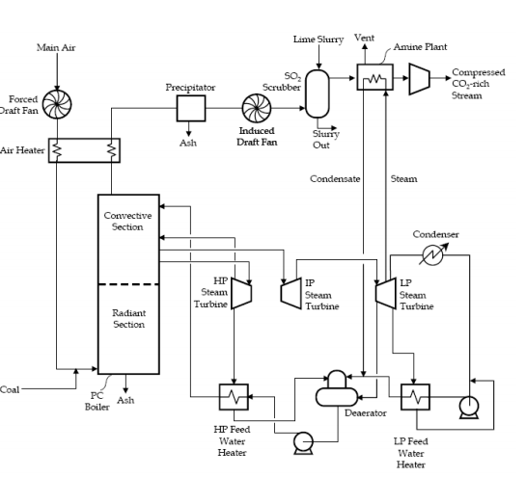
Figure 5: Pulverized coal power plant with Amine Scrubbing for CO₂ capture.
Oxy-fuel Technology
This combustion technology offers a solution to bringing down the cost of capturing CO₂. Large-scale deployment of oxy-fires technology is yet to be actualized, but small-scale demonstrations of its effectiveness have been done. The technology offers improvements in the process of capturing CO₂ from post-combustion flue gases, at least for industrial sites, but for coal power production, there is still no incentive to using the oxy-fuel technology. The oxy-fuel system has three distinct features; the flue gas recycling system, the CO₂ purification, the compression system, and the cryogenic air separation (Wu et al., 2018). Understanding these systems is usually critical in identifying potential problems and the areas that might need improvement.

Cryogenic Air Separation Unit
Since cryogenic oxygen production is a mature technology, minor improvements are always expected to reduce the cryogenic ASU process's energy demand or cost. Currently, the cryogenic ASU process is the method employed in the large-scale production of oxygen. It may probably be the air-separation technology used when oxy-fuel power plants go large-scale. The oxy-fuel systems assume 95% pure oxygen from the ASU, and it can be adjusted up to purities greater than 99% or down. Production of higher purity oxygen is expensive in operating cost and capital (Wu et al., 2018). Studies have indicated that there is a little additional benefit to use oxygen purer than 95%; therefore, the cost of production should not be an issue. When used in an oxy-fuel system, the cryogenic ASU consumes roughly 20% of the plant's gross power output. Thus, by supplanting cryogenic ASU with less expensive and less energy-intensive air separation, a more cost-effective means of reducing the cost of CO₂ capture is achieved.
Flue Gas Recycle
In controlling flame temperature and stability, flue gas recycle is usually critical. It also controls the heat flux properties in the boiler and maintains the boiler temperatures below the ash melting point. Recycling is categorized into two; there is external recycle and internal recycle. The external recycle is characterized by the splitting of the flue gas stream after particulate removal, and the flue gas is delivered back to the boiler through the ductwork. The current state of the art of oxy-fuel combustion systems is anchored on external flue gas recycling due to its efficiency in recycling 60-70% of the flue gas (Wu et al., 2018). The internal recycle processes are used in the steel and glass industry, where high momentum oxygen is required to recycle flow within the boiler.

CO₂ Purification and Compression
Depending on the target use, the requirements for purified CO₂ stream conditions always vary. The CO₂ stream is always expected to be greater than 95% pure and free from non-condensable gases such as Argon, N₂, oxygen, particulate matter, water, and pressurized to about 110 atm (Wu et al., 2018). Figure 6 shows a possible design for a CO₂ purification and compression plant integrated into an oxy-fired power plant.
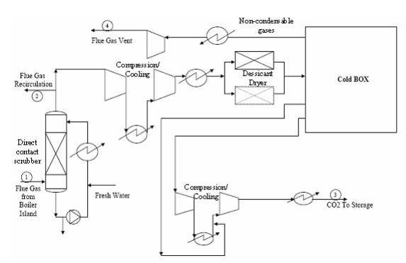
Figure 6: CO₂ purification and compression plant
Pre-combustion Carbon Capture
This capture process involves a primary fuel reaction with air or oxygen and steam to produce a mixture of CO and H₂ (syngas). This technology involves different processes such as steam reforming, partial oxidation, and gasification. The steam reforming process involves the reaction of the primary fuel with the steam, while the partial oxidation process involves the reaction of primary fuel with oxygen and gasification if it is solid fuel involved (Pardemann and Meyer, 2015). Existing technologies that have tapped into using the pre-combustion carbon capture approach are gasification of biomass or coal, light hydrocarbons, steam methane reforming, partial gas oxidation, and auto-thermal reforming of gas. The CO from the syngas mixture is subsequently converted to CO₂ using the shift reactor, a catalytic reactor; the reaction produces additional hydrogen. The processing of the resulting mixture can either be done through a chemical means or physical absorption unit (Pardemann and Meyer, 2015). The H₂ stream in the mixture is then combusted to produce power while the CO₂ is captured.
Chemical Loop Combustion (CLC)
Compared to the other state-of-art technologies for CO₂ capture, CLC arguably stands out for its efficient or rather 100% capture of CO₂ released from power plants. CLC process results in the generation of CO2 enriched flue gas which is critical in capturing CO₂, utilization, or sequestration (Li et al., 2017). The CLC process is an oxygen-transporting process that uses oxygen carriers such as metal oxides (MexOy) to aid in oxygen transportation. The oxygen carrier is usually circulated continuously between two reactors. CLC also incorporates aspects of chemical-looping gasification (CLG) that can be used in the generation of chemical, power, and liquid fuels. In recent years, several CLC research and development reviews have been conducted to establish its effectiveness and its broad applicability in other industries other than the energy industry. Figure 7 below shows a schematic image of the general principle of CLC.
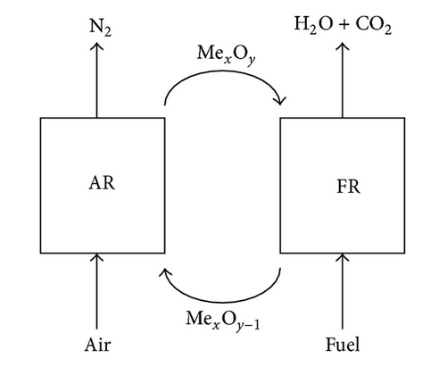
Figure 7: A schematic picture of the CLC process.
The fact that the CLC process involves the separation of carbon in the fuel prior to the combustion and conversion is aided by an oxygen carrier other than by air shows that the technology is both pre-combustion capture and oxy-combustion capture (Li et al., 2017). The CLC technology is the only one that is best suited for capturing CO₂ from flue gases due to efficiency both from the aspects of cost and energy used.
Capture Cost and Plant Efficiency Losses of CCS Technologies
Post-Combustion
CO₂ Capture Cost
One thing that is certain about the capturing process is that it is costly; it increases both the total plant cost (TPC) and the cost of electricity (COE). A study performed to estimate TPC and COE for pulverized coal plants with ultra-supercritical, supercritical, and subcritical steam systems, both with and without capture, showed that adding an amine chemical absorption system increases COE by 57-69%, while the TPC is increased by 54-74% (Delarue et al., 2014). COE and TPC increase is more pronounced in less efficient subcritical systems than for higher efficiency super and ultra-supercritical systems, as shown in figure 8.
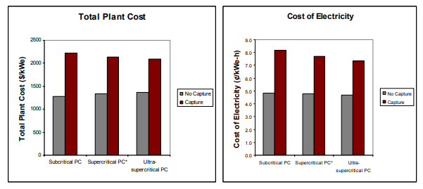
Figure 8: Total plant cost and Cost of electricity for PC plants with and without capture.
Plant Efficiency Losses
The most expensive part of the capture, transport, and storage process is capturing and compressing CO₂. The cost can be expressed in terms of overall plant efficiency losses implying lost electricity production and lost revenue. The losses can be categorized into CO₂ recovery heat, compression energy, and CO₂ recovery power for subcritical PC (Delarue et al., 2014). The CO₂ compression energy is critical in compressing CO₂ for easy transportation and storage. The CO₂ recovery power is the additional power required to drive the flue gas fan and the sorbent pump that moves the amine solvent through the recovery system. On the other hand, the recovery heat is the steam that is used to heat the CO₂ enriched in the regeneration unit.
A typical illustration of subcritical plant losses and how they lower a plant's overall efficiency is shown in figure 9. Supercritical and ultra-supercritical systems can also experience the same losses in terms of category and quantity. However, in these systems, the loss is subtracted from higher original efficiency. For instance, an ultra-supercritical plant with an efficiency of 43.3% loses 9.2 efficiency points just like a subcritical plant.
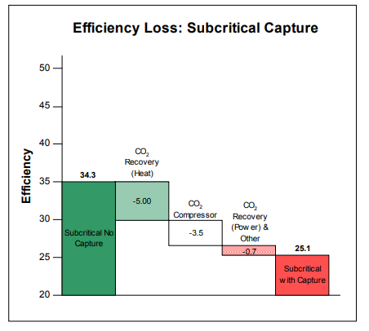
Figure 9: Efficiency losses by category for a subcritical PC plant with capture.
Oxy-fuel Combustion
CO₂ Capture Cost
Studies indicate that using oxy-fueling with CO₂ capture increases TPC by 43% and COE by 46% over a no-capture plant and these statistics are consistent with the other estimates that use the technology in small-scale (Wu et al., 2018). Inasmuch as that is the case, the TPC and COE projections are lower compared to the PC plants according to the commercial amine capture systems as shown in figure 10 below.
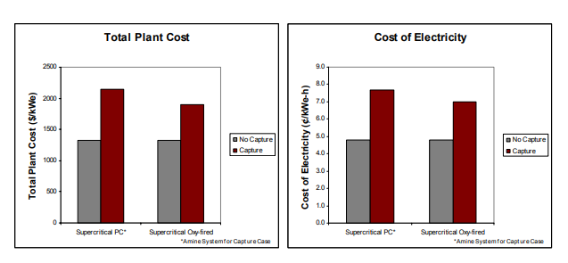
Figure 10: Total Plant Cost (TPC) and Cost of Electricity (COE) for supercritical PC plants without and with Oxy-fuel.
Plant efficiency losses
In this technology, the primary losses can be categorized into compression energy, ASU energy and other losses. These categories require considerable amount of energy which in turn neutralizes this technology’s gained efficiency due to the improvement of boiler and reduced energy usage in the FGD. For instance, large amount of energy is required in the ASU to aid in the primary separation of N₂ from O₂ (Wu et al., 2018). Also CO₂ compression energy is required CO₂ to conditions that will enable transportation and storage. Besides, other energy requirements such as CO₂ purification system and the flue gas fan might also contribute to energy losses. Figure 11 below shows these losses.
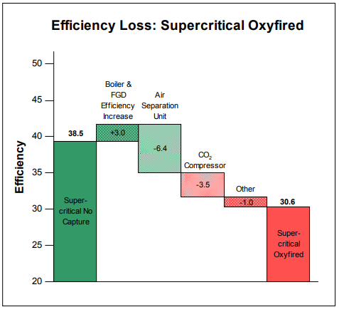
Figure 11: Efficiency losses by category for an oxy-fuel supercritical PC plant with CO2 capture.
Pre-Combustion
CO2 Capture Cost
According to this technology, the TPC for capture is increased only by 32% and the COE increased by only 27% compared to IGCC system with no capture (Pardemann & Meyer, 2015). The figure 12 shows the increase in COE for an IGCC system with and without capture. It points out that CO2 capture is less expensive from an IGCC than from a post-combustion PC.
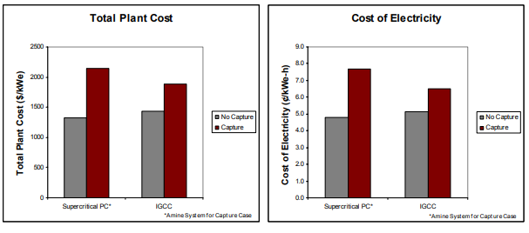
Figure 12: Total plant cost (TCP) and Cost of Electricity for IGCC systems with and without Capture.
Plant Efficiency Losses
The loss in efficiency experienced in this technology is 7.2 percentage points compared to 9.2 percentage point drop for post-combustion PC systems with capture as figure 13 indicates. These technologies’ into WGS reaction and other minor losses such as recovery losses and compression for CO₂.
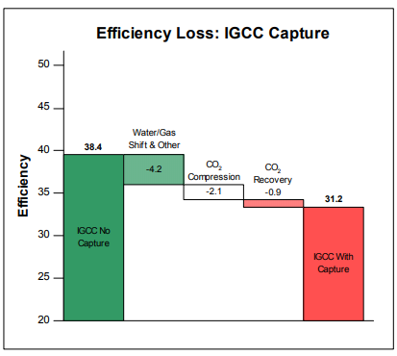
Figure 13: Efficiency losses for an IGCC system with CO₂ capture
Chemical loop Combustion
CO₂ Capture Cost
The CLC system enables adequate solid circulation between fuel and air reactors, thus ensuring adequate contact time between the fuel/air and the metal oxide to achieve complete fuel combustion (Hallberg et al., 2014). The complete fuel combustion results in an endothermic reaction that causes a rise in temperature and pressure operation, thus maximizing power generation efficiency.
Plant Efficiency losses
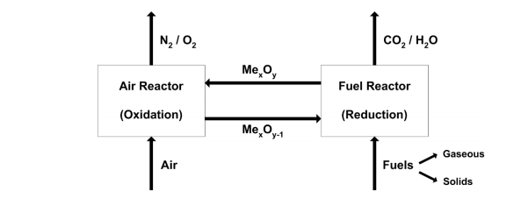
Figure 14: Schematic of the chemical-looping combustion process, which is cycling process that consists of a fuel reactor and an air reactor
As shown in figure 14, the CLC generated heat can be in power generation. CLC’s reduction process (Reaction 1) can either be endothermic or exothermic, while for the oxidation, it is only exothermic. For the endothermic reaction in reaction 1, the solid oxygen carrier cycled between the fluidized beds usually provides the fuel reactor’s heat. Plant efficiency losses with the CLC are very minimal due to the two reactions. The outlet gas from the air reactor usually drives the gas turbine or air turbine. The flue gas drives the CO2 turbine from the fuel reactor. Extra power is generated by the low-pressure steam from the exhaust from the air turbine. Efficiency is maximized by high temperatures in both fuel and air reactors.

Design for different CCS Technologies
Post-Combustion
The concepts of CO₂ capture technology can vary greatly, but a common characteristic is that the capture takes place following combustion and steam generation. Depending on the properties of coal and the boiler configuration, flue gas properties can be highly variable.
In the power industry, reliability is highly valued both from the perspective of the supplier and consumer. The demand for a steady stream of consistent quality power with few or no interruptions or fluctuations in voltage is essential to the consumers. To the producers, high availability is necessary to keep energy costs low and recoup investments (Yoro and Sekoai, 2016). There are many complexities associated with the generation, transmission, and distribution of power, and thus, factors that limit the availability or reliability of plants are highly undesirable. Figure 15 shows how post combustion technology is used in coal power plants.
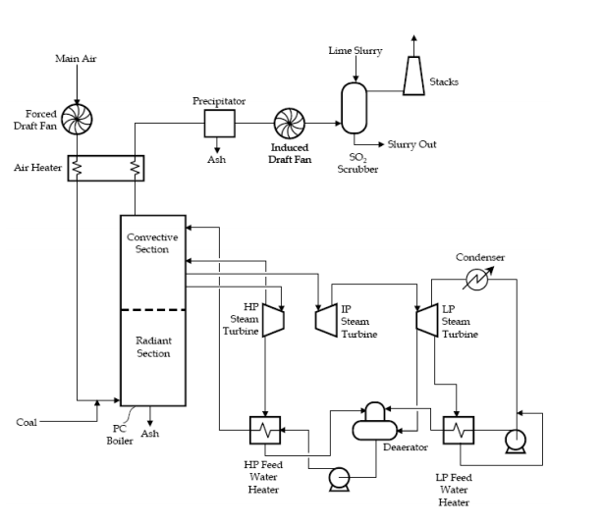
Figure 15: Pulverized Coal Power Plant with CO₂ Capture
One vital characteristic of the post-combustion capture systems is that they are always installed downstream of the system generation system. They are also completely separated from the power block where the generation of electricity takes place (Yoro and Sekoai, 2016). Thus, if the capture system encounters difficulty, power production will not be affected in any way. The plant's operation can continue while the CO₂ is vented to the atmosphere until the capture is brought back into operation. Therefore, a plant with post-combustion capture should be no less reliable than a similar plant without capture since, in case of any breakdown, operations continue.
Oxy-fuel Combustion
For this design, the feed system, the boiler system, and the ESP are essentially the same, but a portion of the flue gas is recycled following the ESP, and cryogenic ASU is used in the provision of 95% pure oxygen to the boiler as figure 15 indicates (Wu et al., 2018). The design involves the primary separation of N₂ and O₂ before combustion is initiated. The separation is key to ensure that flue gas is primarily made of CO₂ and water vapor. Thus, as a result of the separation, CO₂ purification, transportation, and storage are made easier and less expensive. The flue gas recycle step is necessary to control flame temperature and stability, thus ensuring proper heat flux in the boiler. Supercritical steam cycles at around 3530 psi and 1050 F characterize the design of oxy-fuel systems. Also, the O₂ content of the gas fed to the boiler is typically high, around 30%, compared to the 21% O₂ gas that is usually fed to the conventional boiler (Wu et al., 2018). The high CO₂/H₂O gas in the furnace has a higher gas emissivity, which allows the same radiative heat transfer with a smaller volume of boiler gases than a PC system. The flue gas volume before CO₂ purification and compression is decreased by about 80%. However, it is a higher density gas and has higher concentrations of contaminants per volume or per mass basis.
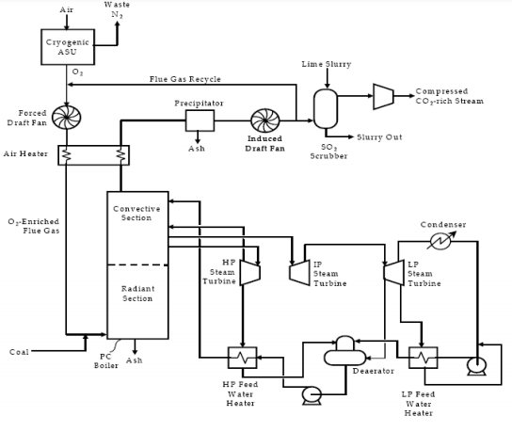
Figure 16: Oxy-fuel pulverized coal power plant with CO₂ capture
The oxy-fuel boilers and burners have extensive operating histories in the steel and glass industries, thus have perfect reliability and operability characteristics. The heat capacity and the heat transfer characteristics are the key differences between air-fueled and oxy-fueled systems. This difference affects how heat is transferred from the boiler into the steam system and how stable the flame is (Wu et al., 2018). Studies have indicated that the boiler's performance improves with oxy-fueling due to better heat transfer characteristics even though the stability of the flame is sometimes compromised. Thus, to ensure a stable flame, a higher oxygen concentration must be maintained in the boiler. In this design, the reliability and operability is only compromised if SO₂ is co-captured with the CO₂ and the CO₂ equipment goes down; the concentration of SO₂ in the flue gas would be too high to vent the stream to the atmosphere as figure 16 illustrates. Thus, for a continuous operation to be ensured, there must be a system to control the SO₂ (Wu et al., 2018). If these measures are considered, then the plant may continue operating even if a problem is encountered in the purification and compression systems.

Pre-Combustion
Compared to post-combustion capture, major changes must always be made to the pre-combustion systems' core process to ensure the capture of CO₂ as shown in figure 17. In this system, water gas shift (WGS) is specifically added to the reactor, in which the CO reacts with H₂O forming CO₂ and H₂. A separation process is then initiated to remove the CO₂ from the shifted syngas stream (Pardemann & Meyer, 2015). The separation process can be either through the physical and chemical absorption process. The removed CO₂ is further compressed through dehydration, and the remaining gas stream of nearly pure H₂ is combusted in the gas turbine.
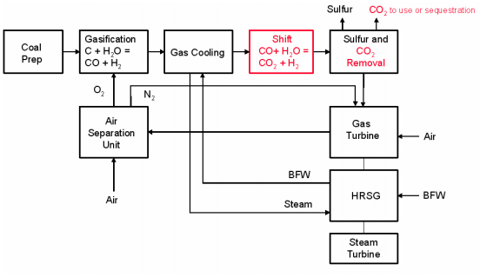
Figure 17: Pre-combustion system with CO₂ capture
The problem with capturing CO₂ with this system is that the capture tool is central to the whole process's operation. Thus, if there is a problem with any of the capture equipment, the whole system goes down, thereby halting power generation. This contrasts with the post-combustion system, where the plant can operate effectively even if the capture equipment is out of operation, and the CO₂ can be vented into the atmosphere for a considerable time (Pardemann & Meyer, 2015). The pre-combustion system is very unfavorable for plant operations, at least from an economic perspective.
Chemical loop Combustion
The CLC performs various, thus enabling one to avoid the need for a two-step operation: WGS reaction to increasing the content of CO₂ in the gas stream and separation unit for CO₂ capture. As illustrated in figure 18, the hot gas cleanup unit is essential to remove most of the Sulphur in the raw syngas before entering the CLC unit. Through the gas-solid reaction with a metal oxide, the syngas entry into the CLC reducer results in its conversion to CO₂ and H₂O (Wang et al., 2015). The reduced metal oxide then reacts with air in the combustor. Through cooling and capturing, the CO₂ and H₂O are separated, and the regenerated hot air is allowed to run through an expander for power generation
.

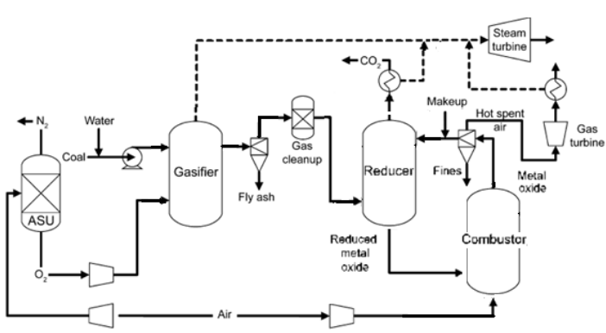
Figure 18: Schematic diagram of CLC process
The use of CLC has steadily been increasing over the years, as suggested by the many tests that have been carried out to establish its effectiveness and efficiency in the generation of power. Significant strides have been made as far as industrial demonstration with gaseous fuel is concerned. The CLC system enables adequate solid circulation between fuel and air reactors, thus ensuring that there is satisfactory contact time between the fuel/air and the metal oxide to achieve complete fuel combustion (Wang et al., 2015). The complete fuel combustion results in an endothermic reaction that causes a rise in temperature and pressure operation, thus maximizing the efficiency of power generation.
Conclusion
The ever-increasing threat of global warming has had many worried about the implications that continue to be witnessed every day. The world’s continued reliance on fossil fuels has put us at loggerheads with nature which has been very unforgiving. The debate on moving towards a carbon-free power sector has featured globally, but it has done little to reduce people’s urge for non-renewable energy sources such as fossil fuels. One thing that this debate might have brought to light is the CSS technologies that have today continued to show capability cleaning the atmosphere of excess CO₂. These technologies have been in existence for quite some time, although they were being used for other purposes, and it is just in the two or so decades that the world has realized that they can help mitigate global warming. Even though these CCS technologies cannot provide a low carbon solution amongst all of the energy sectors, they can considerably reduce CO₂ generated in the power sector by approximately 70%. These CCS technologies include the post-combustion system, pre-combustion system, oxy-fuel combustion system, and chemical-loop combustion system. These systems operate differently, and their use is heavily dependent on the type of plant and fuel used. Among the four, the CLC offers the best option for capturing CO₂ due to the less energy that is needed to considerably reduce the amount of CO₂ released into the atmosphere through the burning of fossil fuel to power. Thus, since the world is not yet ready to embrace renewable sources of energy, the incorporation of CLC systems that can be easily used in the power industry might be a viable solution. The less energy used in the capture of CO₂ brings out the cost-effectiveness of the system.

References
Abdelaal, A., Gajbhiye, R., & Al-Shehri, D. (2020). Mixed CO2/N2 foam for EOR as a novel solution for supercritical CO2 foam challenges in sandstone reservoirs. America Chemical Society Omega, 5(51), 33140-33150. doi: 10.1021/acsomega.0c04801
Bachu, S. (2015). Review of CO2 storage efficiencyy in deep saline acquifers. International Journal of Greenhouse Gas Control, 40, 188-202. doi:doi.org/10.1016/j.ijggc.2015.01.007
Bui, M., Anthony, E. J., Brown, S., Galindo, A., Bardow, A., Adjiman, C. S., & Fuss, S. H. (2018). Carbon capture and storage (CCS): The way forward. Energy Environment Science, 11, 1062-1176.
Delarue, E., D'haeseleer, W., & Martens, P. (2014). Market opportunities for power plants with post-combustion carbon capture. International Journal of Greenhouse Gas Control, 279-288.
Hallberg, P., Dazheng, J., Jasper, N., Lyngfelt, A., Ryden, M., Kallen, M., & Snijkers, F. (2014). Experimental investigation of CaMnO3 based oxygen carriers used in continuous chemical-looping combustion. International Journal of Chemical Engineering. doi:https://doi.org/10.1155/2014/412517
Johnson, F., Goransson, L., & Mikel, O. (2014). Challenges to integrate CCS into low carbon electricity markets. Energy Procedia, 63, 7485-7493.
Kelsall, G. (2020). Carbon capture utilization and storage- status, barriers and potential . Clean Coal Center, 1-93.
Li, J., Zhang, H., Gao, Z., Dai, J., Fu, J., & Ao, W. (2017). CO2 capture with chemical looping combustion of gaseous fuels: An overview. Energy Fuels, 31, 3475-3524.
Matsuno, T., Maruyama, K., & Tsutsui, J. (2012). Stabilization of atmospheric carbon dioxide via zero emissions-An alternatie way to a stable global environment. Part 1: Examination of the traditional stabilization concept. Proceedings of the Japan Academy, Series B Physical and Biological Sciences, 88(7), 368-384. doi:10.2183/pjab.88.368
Pardemann, R., & Meyer, B. (2015). Pre-combustion carbon capture. Handbook for Clean Energy System, 1-28.
Sifat, N. S., & Haseli, Y. (2019). A critical review of CO2 capture technologies and prospects for clean power generation. Energies, 12(21). Retrieved from 10.3390/en12214143
Thompson, A. (2014). Major greenhouse gas reduction needed by 2050: IPCC. Climate Central. Retrieved from https://www.climatecentral.org/news/major-greenhouse-gas-reductions-needed-to-curtail-climate-change-ipcc-17300
Wang, P., Shekhawat, D., Berry, D., Massoudi, M., & Means, N. M. (2015). Chemical-looping combustion and gasification of coals and oxygen carrier development: A brief review. Energies, 8, 10605-10635. doi:doi:10.3390/en81010605
Wilberforce, T., Baroutaji, A., Soudan, B., Al-Alami, A. H., & Olabi, A. G. (2019). Outlook of carbon capture technology and challenges. Science of Total Environment, 657, 56-72.
Wu, F., Dellenback, P. A., Fan, M., & Argyle, M. D. (2018). Progress in O2 separation for oxy-fuel combustion-A promising way for cost-effective CO2 capure: A review. Program Energy Combsution Science, 67, 188-205.
Yoro, K., & Sekoai, P. (2016). The potential of CO2 capture and storage technology in South Africa's coal-fires thermal plants. Environments, 3(24).
Zainab, Y. T., & Oboirien, B. O. (2020). Process modelling of chemical looping combustion of paper plastics, paper/plastic blend waste, and coal. American Chemical Society, 5(35), 22420-22429. doi:doi.org/10.1021/acsomega.0c02880

